Prepare the Full Paper Using this Template for IAHR 2011 (Times New Roman 18pt bold)
John Smith¹, Author 2¹ and Author 3² (Times New Roman 12pt bold)
¹Department of Mechanical Engineering, Xxxx University (Times New Roman 12pt)
Address, City, Postal Code, Country, author1@email.net, author2@email.net
²Department of Mechanical Engineering, Xxxx University
Address, City, Postal Code, Country, author3@email.net
Abstract (Times New Roman 11pt bold)
The aims, scope and main conclusions of the paper must be in a self-contained abstract of a single paragraph. The abstract must be informative and not just indicative and contain a summary of the significant results reported in the paper. No references should be cited. Avoid mathematical expressions as far as possible. Just below the abstract, up to six keywords related to the paper topic should be provided. (Times New Roman 10 pt)
Keywords: Up to six keywords should be provided. (Times New Roman 10 pt)
- Introduction (Times New Roman 12pt bold)
The paper should use the following page setup: paper size A4 and margins as top: 12.5 mm, bottom: 12.5 mm, left: 12.5 mm and right: 12.5 mm. The paper should be typed using Times New Roman 10pt and with single spacing between text lines. Each paper will be assigned a Digital Object Identifier (DOI) by the publisher.
This section describes the background and objectives of the work.
- Submission of full-length paper (Times New Roman 12pt bold)
The full - length paper should be submitted at the wg2011@mas.bg.ac.rs . The full-length paper should be in English. Submission of a paper implies that the work described has not been published previously, that it is not under consideration for publication elsewhere, and that, if accepted, it will not be published elsewhere in the same form.
- Publishing agreement (Times New Roman 12pt bold)
The authors warrant that the paper is the author’s original work and has not been published before (if excepts from copyrighted works, figures, diagrams, photos, trademarks or other such materials are included, the author will obtain written permission from the copyright owner and show credit to the sources in the manuscript). The author also warrants that the paper describes genuine research or review work, contains no libelous or unlawful statements and does not infringe on the rights of others. The author(s) agree that their paper be published on the 4th IAHR WG Meeting proceedings.
- Full-length Paper Preparation (Times New Roman 12pt bold)
Detailed instructions on full-length paper preparation are listed below. The full-length paper will be submitted no later than May 31st, 2011. The full length paper will be reviewed by the International Scientific Committee.
The full-length paper should be prepared using the present template.
4.1 General (Times New Roman 10pt bold)
The full-length paper should be submitted both in a doc file (generated with MS Word) and PDF file.
The paper will not exceed 8 pages. Colored figures can be included but it is recommended to set the file size to be maxim 5MB. Be sure to embed in the file all the fonts used in the manuscript and to make the manuscript readable with Adobe Acrobat Reader 5.0 or later.

4.2 Layout (Times New Roman 10pt bold)
Place figures and tables where they are referred to for the first time in the main text. Number all pages consecutively.
4.3 Elements of a Paper (Times New Roman 10pt bold)
The basic elements of a paper are title, author names and affiliations, abstract and keywords, body of paper, acknowledgments, appendices, nomenclature, references, which should be presented in the order suggested. The figures and tables should be placed where they are referred to for the first time in the body of the paper.
- Body of Paper (Times New Roman 12pt bold)
This section should contain sufficient details so that study/experimental procedures can be repeated/duplicated by others, in conjunction with references.
A clear presentation of numerical and/or experimental results obtained, highlighting any trends or points of interest.
5.1 Originality (Times New Roman 10pt bold)
If the material has been published elsewhere and the paper does not include new understanding of the material or new idea, it cannot be accepted.
5.2 Reliability (Times New Roman 10pt bold)
The paper should not include any apparent errors in the main body of theory, equations, experiments and understanding of the results.
5.3 Expression and Structure (Times New Roman 10pt bold)
The expressions and the structure should be clear and concise. The paper should present proper logics and discussions on the results obtained.
5.4 Mathematics (Times New Roman 10pt bold)
Particular care should be exercised in identifying all symbols and in avoiding ambiguities. Equations will be prepared in MS Word equation editor with following set-up: style/define (Text, Matrix-Vector, Number: Times New Roman (without bold or italic), LC Greek, UC Greek: Times New Roman (without bold or italic) and Function, Variable: Times New Roman with italic) and size/define (Full 12pt, Subscript/Superscript 7pt, Sub- Subscript/Superscript 5pt, Symbol 18pt and Sub- symbol 12pt). Equation numbers should appear in parenthesis and be numbered consecutively. All equation numbers must appear on the right-hand side of the equation. Equations can be referenced within the text as “eq. (1).” When the reference to an equation begins a sentence, the abbreviation “eq.” should be spelled out, e.g., “Equation (1).”

${\text{Nu}}_{a}=\frac{\int_{A_{d}}{{\text{Nu}}/{{\text{Nu}}_{0}}\text{dA}}}{A_{d}}$ (1)

Table 2 Reference and optimal shape
Shapes | Variables |  |  | Objectives |  | Objective function
Shapes | H/d | H_{d}/d | d/S | Nu_{a}/Nu₀ | F_{f} | F_{surrogate} | F_{RANS} | F_{experimental}
Reference (RANS) | 1.155 | 0.289 | 0.499 | 2.279 | 1.710 | - | 0.5927 | -
Optimal (by PBA) | 0.219 | 0.264 | 0.318 | 5.065 | 2.224 | 0.3909 | 0.3975 | -

5.5 Figures (Times New Roman 10pt bold)
The figures should be clear and large enough so that all letters in the figures are readable. All figures should be placed where they are referred to for the first time and be numbered consecutively and have a proper caption. This number should be used when referring to the figure in text. Figure references should be included within the text in numerical order according to their order of appearance. Figures should be referenced within the text as “Fig. 1.” When the reference to a figure begins a sentence, the abbreviation “Fig.” should be spelled out, e.g., “Figure 1.”

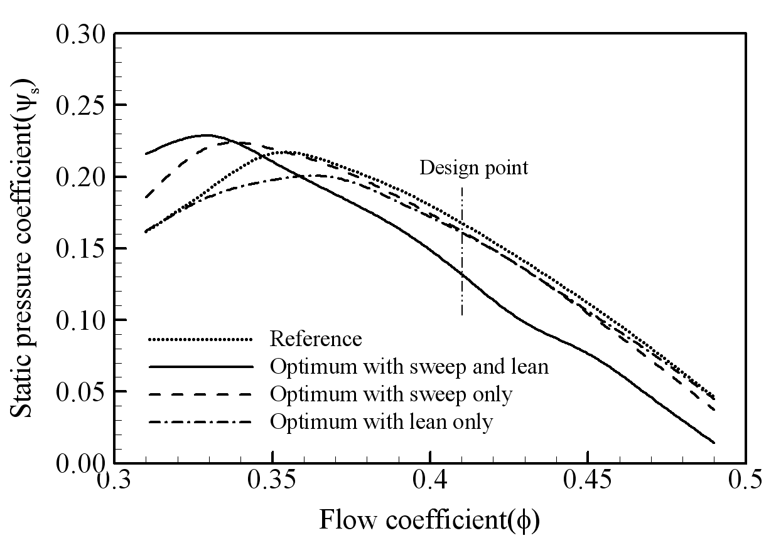
Fig. 1 Comparison of performance curves between optimum and reference blade shapes
5.6 Tables (Times New Roman 10pt bold)
All tables should be placed where they appear in the text for the first time and should be numbered consecutively and have a proper caption. This number should be used when referring to the table in text. Table references should be included within the text in numerical order according to their order of appearance.
- Conclusion (Times New Roman 12pt bold)
This section should be a brief explanation of the significance and implications of the work reported. If you have any question regarding these format instructions, please contact the IAHR organizers by email: wg2011@mas.bg.ac.rs
- Appendix (Times New Roman 12pt bold)
Use Appendix only if necessary to clarify the paper. Note that appendices are included in the 8 pages full-length paper submitted for publication.
Acknowledgments (Times New Roman 12pt bold)
Acknowledgments may be made to individuals or institutions that have an important contribution in supporting or developing the work included in the paper.
Nomenclature (Times New Roman 12pt bold)
The nomenclature list should be in alphabetical order with Greek symbols, also in alphabetical order and with a separate heading, following the alphabetical listing. Subscripts and superscripts should follow Greek symbols and should be identified with separate headings.

A_{c}  L_{x}  R_{th}  Re | Cross-section area of micro-channel [m²]  Length of heat sink [m]  Thermal resistance [ ºC/W]  Reynolds number (=U_{b}D_{h}/ν) | T  U_{i}  θ, φ  ρ | Local mean temperature [K]  Mean velocity components (i=1, 2, 3)  Design variables, W_{c}/H_{c} and W_{w}/H_{c}  Fluid Density
References (Times New Roman 12pt bold)
All publications cited in the text should be presented in a list of references following the text of the manuscript. In the text, make references using a number in square brackets on the line (e.g. Kim and Park [1]) and the full reference should be given in a numerical list at the end of the text. References should be styled and punctuated according to the following examples: journal article [1], book [2], thesis [3], report [4]; proceedings [5], and patent [6].

[1] Stazizar, A. J., 1985, “Investigation of Flow Phenomena in a transonic Fan Rotor Using Laser Anemometry”, ASME Journal of Engineering for Gas Turbines and Power, Vol. 107, No. 2, pp. 427-435.
[2] Myers, R. H. and Montgomery, D. C., 1995, Response Surface Methodology: Process and product optimization using designed experiments, John Wiley & Sons, New York.
[3] Guinta, A. A., 1997, “Aircraft Multidisciplinary Design Optimization Using Design of Experimental Theory and Response Surface Modeling Methods”, Ph. D. Thesis, Department of Aerospace Engineering, Virginia Polytechnic Institute and State University, Blacksburg, VA.
[4] Jameson, A., Schmidt, W., and Turkel, E., 1981, “Numerical Solutions of the Euler Equation by Finite Volume Methods Using Runge-Kutta Time Stepping Schemes”, AIAA 81-1259.
[5] Denton, J. D., Xu, L., 2002, “The Effects of Lean and Sweep on Transonic Fan Performance”, ASME Turbo Expo, Amsterdam, Netherlands, GT-2002-30327.
[6] T. Burns, 1995, US Patent No. 358498.

Copyrights

Work submission will be interpreted as declaration that the author obtained the necessary authorization for publication.

